Interpretable Visual Features for Demand Neuroforecasting

Introduction

Recent advancements in machine learning and demand estimation have explored the integration of novel data types, such as images and text, into traditional models. These approaches have been shown to enhance demand predictions and offer insights for improved aesthetic design (Burnap, Hauser, and Timoshenko 2023; Sisodia, Burnap, and Kumar 2024). Despite these successes, existing research has remained largely agnostic about the underlying mechanisms that explain why image data improves demand estimation.

Meanwhile, consumer neuroscience has provided compelling evidence that neural activity (in the nucelus accumbens, or NAcc) can predict large-scale, out-of-sample outcomes, such as viral YouTube videos or crowdfunding success (Genevsky and Knutson 2015; Tong et al. 2020). However, "neuroforecasting" has largely avoided attributing psychological meaning to the neural activity due to concerns about reverse inference (Poldrack 2006). Thus, a critical open question remains: Why do neural signals contain predictive value for consumer demand?

Both literatures have established that images and neural activity from images contain market-level information, but neither explains why. Genevsky, Tong, and Knutson (2025) suggest that neural activity predicts demand because individual utility functions contain a shared, common component across individuals and an idiosyncratic component unique to each person. In quantitative marketing, this shared component is typically estimated with observable variables, while the idiosyncratic component is often modeled as a distribution of errors. Building on the neural random utility model (Webb 2019), Genevsky et al. (2025) argue that neuroforecasting succeeds because it directly measures this common utility component from early affect brain regions. In contrast, survey responses contain additional idiosyncratic variability, which reduces their predictive power relative to this common component.

Building on these insights, this project pursues two key objectives. First, we adapt a generative machine learning framework (Ludwig and Mullainathan 2024) to uncover the visual features of vehicle images that correlate with the common component of utility. Second, we will attempt to show that these identified visual features can inform the design of survey questions that outperform traditional stated-preference methods in demand forecasting.

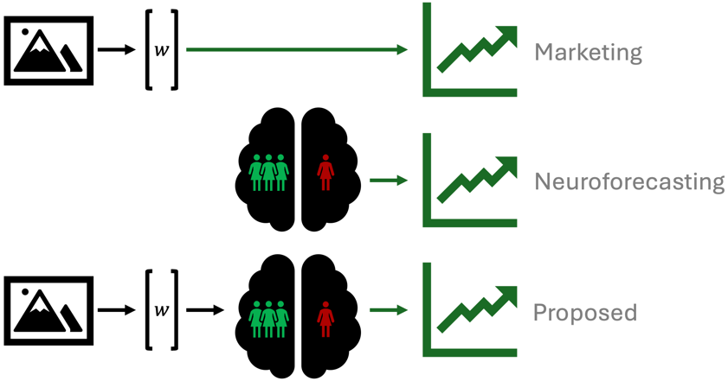
Figure 1. Frameworks for Demand Forecasting. Recent advances in marketing use latent features from image data to improve demand forecasting. Neuroforecasting uses neural activity from the point of stimulus observation to improve demand forecasting. We propose using latent features to understand neural activity. Coupled with generative AI and advancements in feature disentanglement, this gives us a means to interpret visual features that drive neural activity and consumer demand.

Part 1: Using Generative Machine Learning to Identify Psychological Features of an Image

In the first part of our study, we employ generative artificial intelligence ("generative AI") to decompose an image of a vehicle into a vector of latent features. Through regularization techniques, we isolate the latent features most correlated with neural activity in the NAcc. By manipulating only one feature at a time and generating new images based on these manipulations ("latent space traversal"), we can ask human participants to describe what is changing across the manipulated images. This process enables us to interpret which visual features of a vehicle are correlated with early affective responses in the brain. Importantly, at this stage, we are not yet relating these visual features to consumer demand.

Methods

Experiment and Participants. We reuse two fMRI datasets that measured neural activity in the NAcc in response to viewing vehicle images and names (Christiano et al. 2025). The dataset includes 45 participants from around the Stanford University community who all self-reported an intention to purchase a car within the next three years. Participants viewed a total of 38 unique vehicle images while in an fMRI scanner. For each participant, the average percent change in NAcc activity was measured 8 seconds after a vehicle image was presented. For each unique vehicle, neural activity was then averaged across participants to obtain a measure of average neural response.

Procedure. We use an Adversarial Latent Autoencoder, called StyleALAE, for its ability to reconstruct images, learn a meaningful latent space, and ensure disentangled latent features (Pidhorskyi, Adjeroh, and Doretto 2020). The model is trained on 133,372 images of North American gas- and electric-powered vehicles from 2000 to 2025.

Once trained, the model’s encoder outputs a vector of latent features for any given image. These feature values lack human-interpretability at first. To determine their significance, we run a regularized regression of average neural activity for each vehicle on its latent features, identifying those that best explain neural responses.

Using "latent space traversal," we interpret these features by generating new images that manipulate a single feature at a time (see Figure 2). We present manipulated vehicle images to online observers (e.g. MTurk) and ask, "What is changing across these images?" This process allows us to assign human-interpretable meaning to the most important visual features driving early affective brain responses.

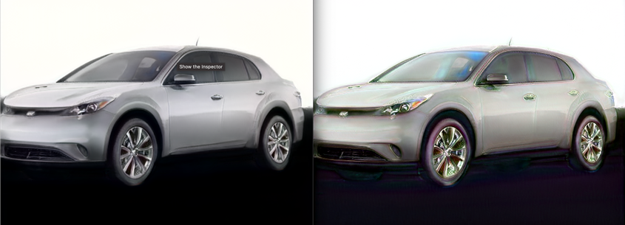
Figure 2. Example of latent space traversal. (Left) A generated image of a car. (Right) A manipulated image where we adjust the “metallic shine” of the vehicle.

Part 2: Using Identified Psychological Features to Design Survey Questions

Having identified the visual features most correlated with neural activity in early affective brain regions, we leverage these insights to design improved survey questions. Rather than relying on traditional stated-preference questions that ask consumers about hypothetical purchasing decisions, we focus on targeted judgments of visual features that drive neural activity in the NAcc. By shifting survey design toward attributes that reflect common components of utility, we hypothesize that responses will align more closely with actual market behavior.

Discussion

By bridging insights from machine learning, neuroscience, and marketing, our study contributes to both theoretical understanding and practical application in demand forecasting. Understanding why image data and neural activity enhance demand estimation allows for more interpretable and generalizable predictive models. Moreover, by using neural data to identify visual features that shape consumer choice, we introduce novel improvements to stated preference methods, leading to better market predictions for businesses and policymakers.

Beyond improved prediction and model interpretability, our framework offers significant efficiency gains. Since our machine learning model requires training only once, it could eliminate the need for multiple fMRI studies in demand forecasting within a given industry—though applicability may be limited by time-sensitive trends. Once established, our model can quickly generate demand forecasts for new products, reducing both research costs and time-to-market. Finally, this research will provide insight into the role of neural data in explaining choice data, providing an interpretation for measurements of our shared utility.

References
Burnap, Alex, John R. Hauser, and Artem Timoshenko (2023), “Product Aesthetic Design: A Machine Learning Augmentation,” Marketing Science, 42(6), 1029–56.
Christiano, Dylan, Cynthia Wu, Nicole Deng, Shabnam Hakimi, Matthew Klenk, Charlene Wu, and Brian Knutson (2025), “Neuroforecasting Changes in Aggregate Demand for Vehicles.”
Genevsky, Alexander and Brian Knutson (2015), “Neural Affective Mechanisms Predict Market-Level Microlending,” Psychological Science, 26(9), 1411–22.
Genevsky, Alexander, Lester C Tong, and Brian Knutson (2025), “Neuroforecasting Reveals Generalizable Components of Choice,” ed. Yannis Yortsos, Pnas Nexus, 4(2), pgaf029.
Ludwig, Jens and Sendhil Mullainathan (2024), “Machine Learning as a Tool for Hypothesis Generation,” The Quarterly Journal of Economics, 139(2), 751–827.
Pidhorskyi, Stanislav, Donald Adjeroh, and Gianfranco Doretto (2020), “Adversarial Latent Autoencoders,” http://arxiv.org/abs/2004.04467.
Poldrack, Russell A. (2006), “Can Cognitive Processes Be Inferred from Neuroimaging Data?,” Trends in Cognitive Sciences, 10(2), 59–63.
Sisodia, Ankit, Alex Burnap, and Vineet Kumar (2024), “Generative Interpretable Visual Design: Using Disentanglement for Visual Conjoint Analysis,” https://papers.ssrn.com/abstract=4151019.
Tong, Lester C., M. Yavuz Acikalin, Alexander Genevsky, Baba Shiv, and Brian Knutson (2020), “Brain Activity Forecasts Video Engagement in an Internet Attention Market,” Proceedings of the National Academy of Sciences, 117(12), 6936–41.
Webb, Ryan (2019), “The (Neural) Dynamics of Stochastic Choice,” Management Science, 65(1), 230–55.

